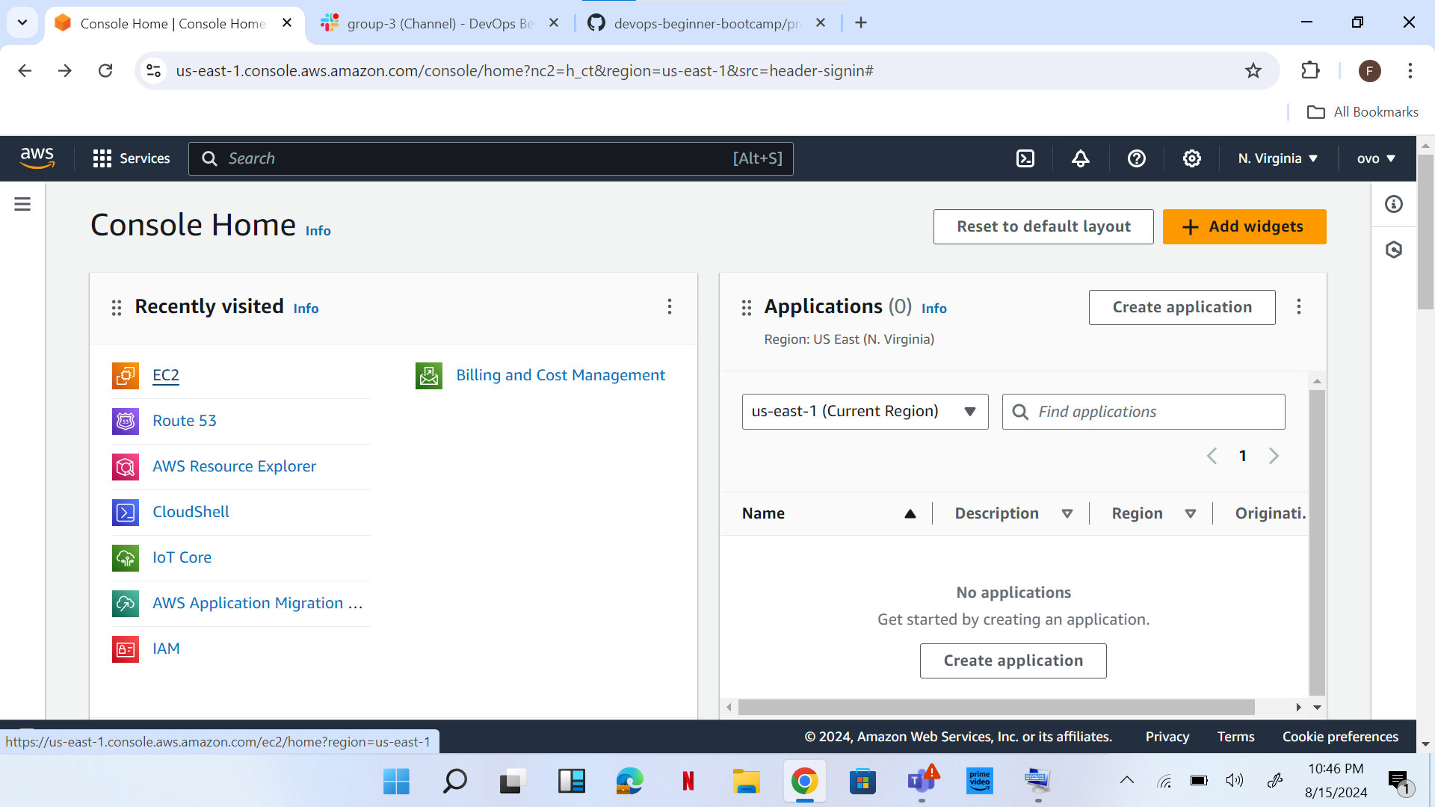

On the console home I clicked on EC2, clicked on launch instance. I was able to access Launch Instant page.

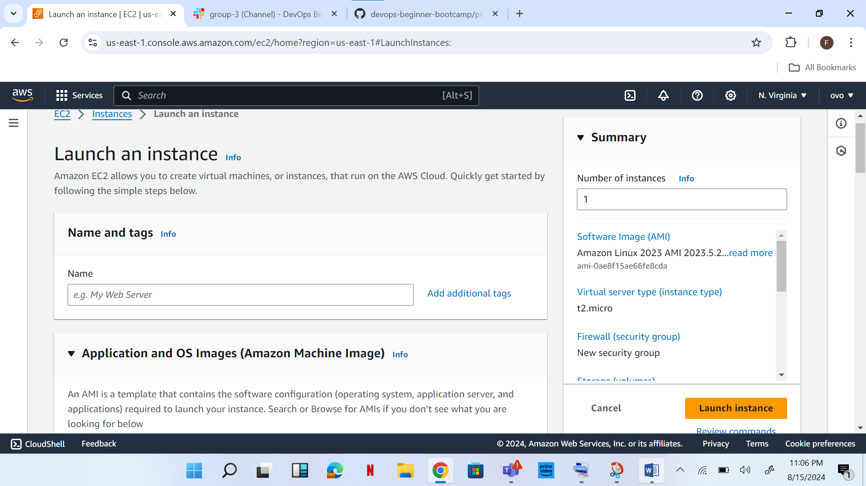

Name: p1 [I have to use p1, cos I made a mistake with the earlier one I did with project1]. I chose Ubuntu. SSH, HTTP and HTTPS access were chosen

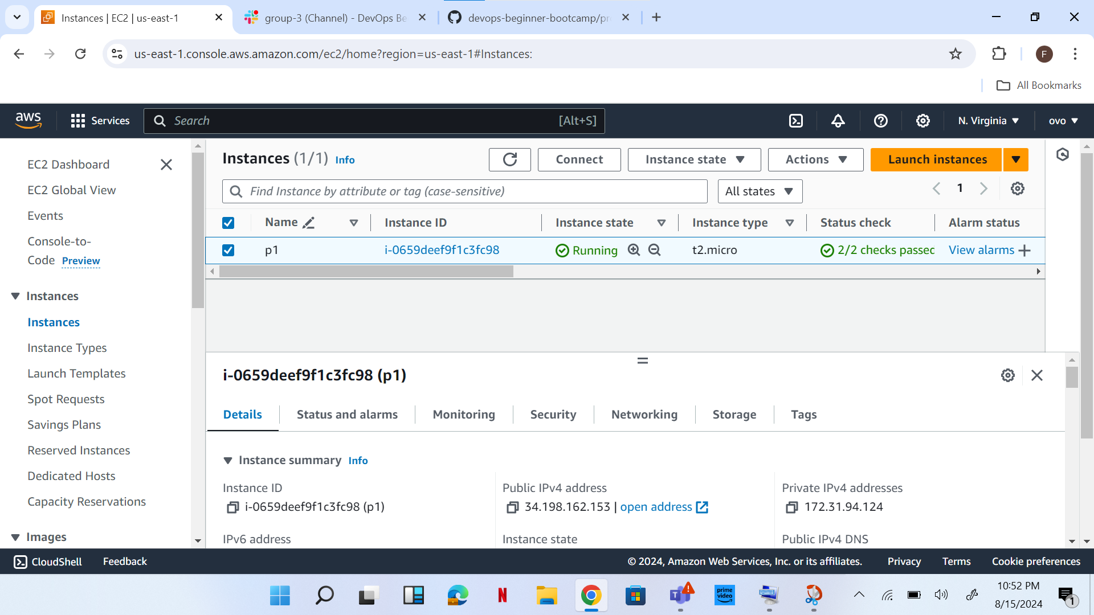

Instance launched.

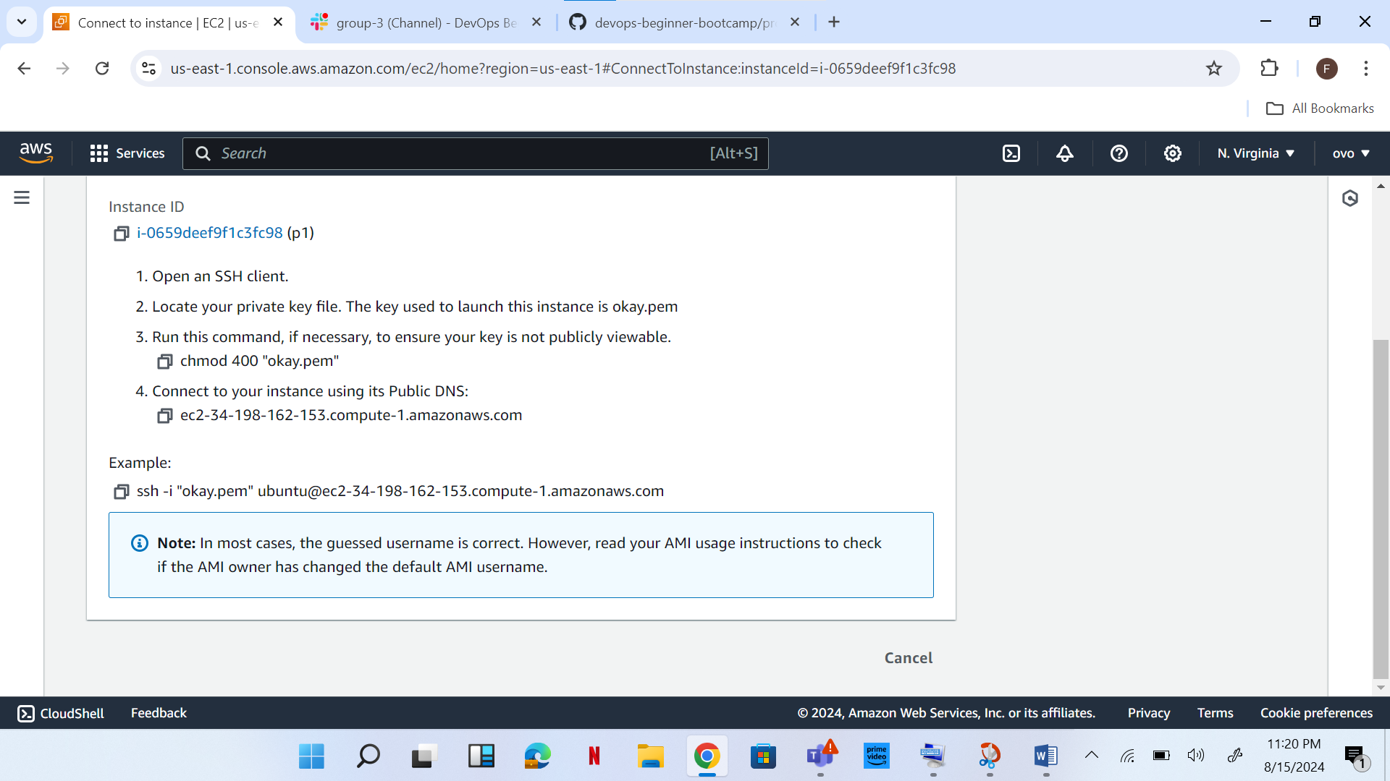

After clicking on connect. I copied the command on SSH client.

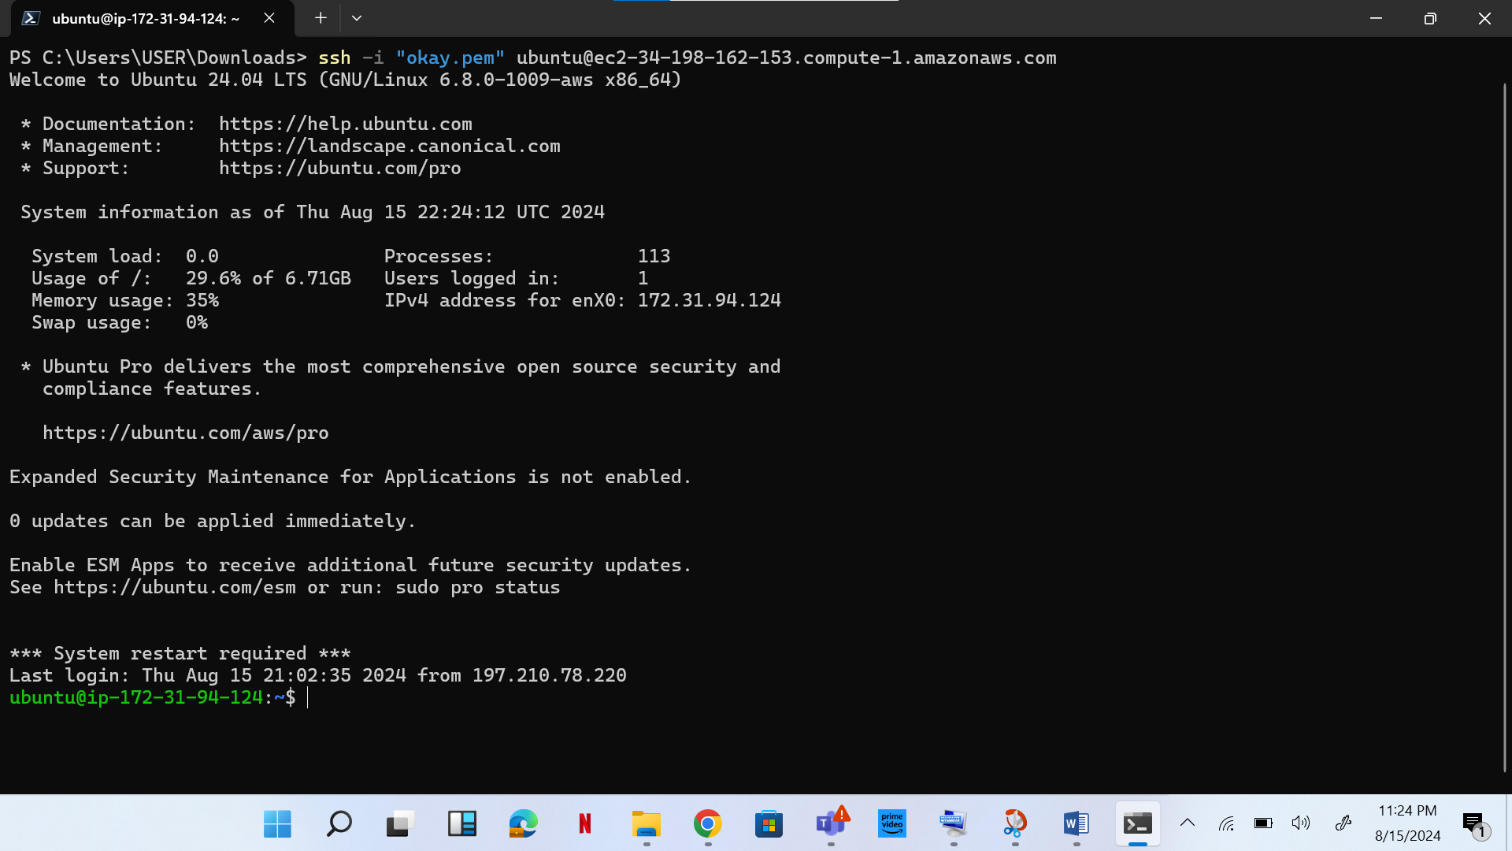

Opened a terminal on my .pem file, okay.pem was was downloaded. I pasted the SSH command and pressed enter key.

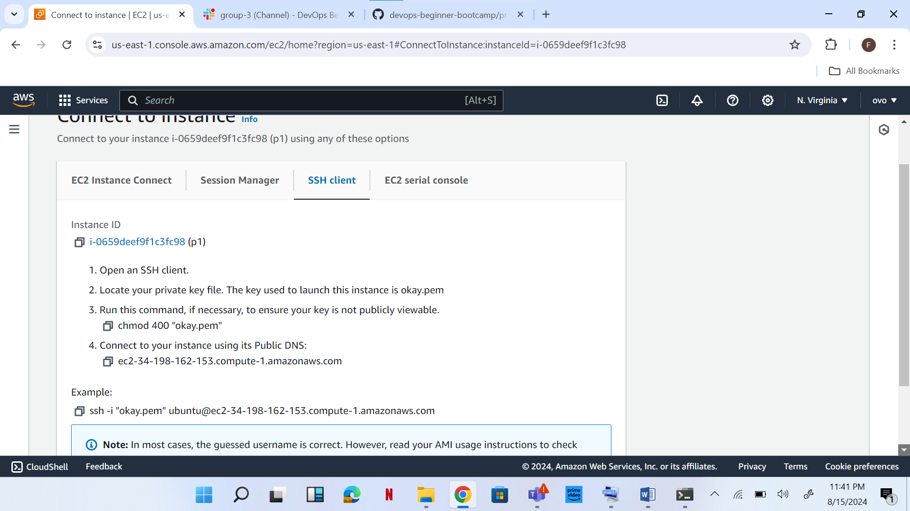

An elastic IP was created and associated.

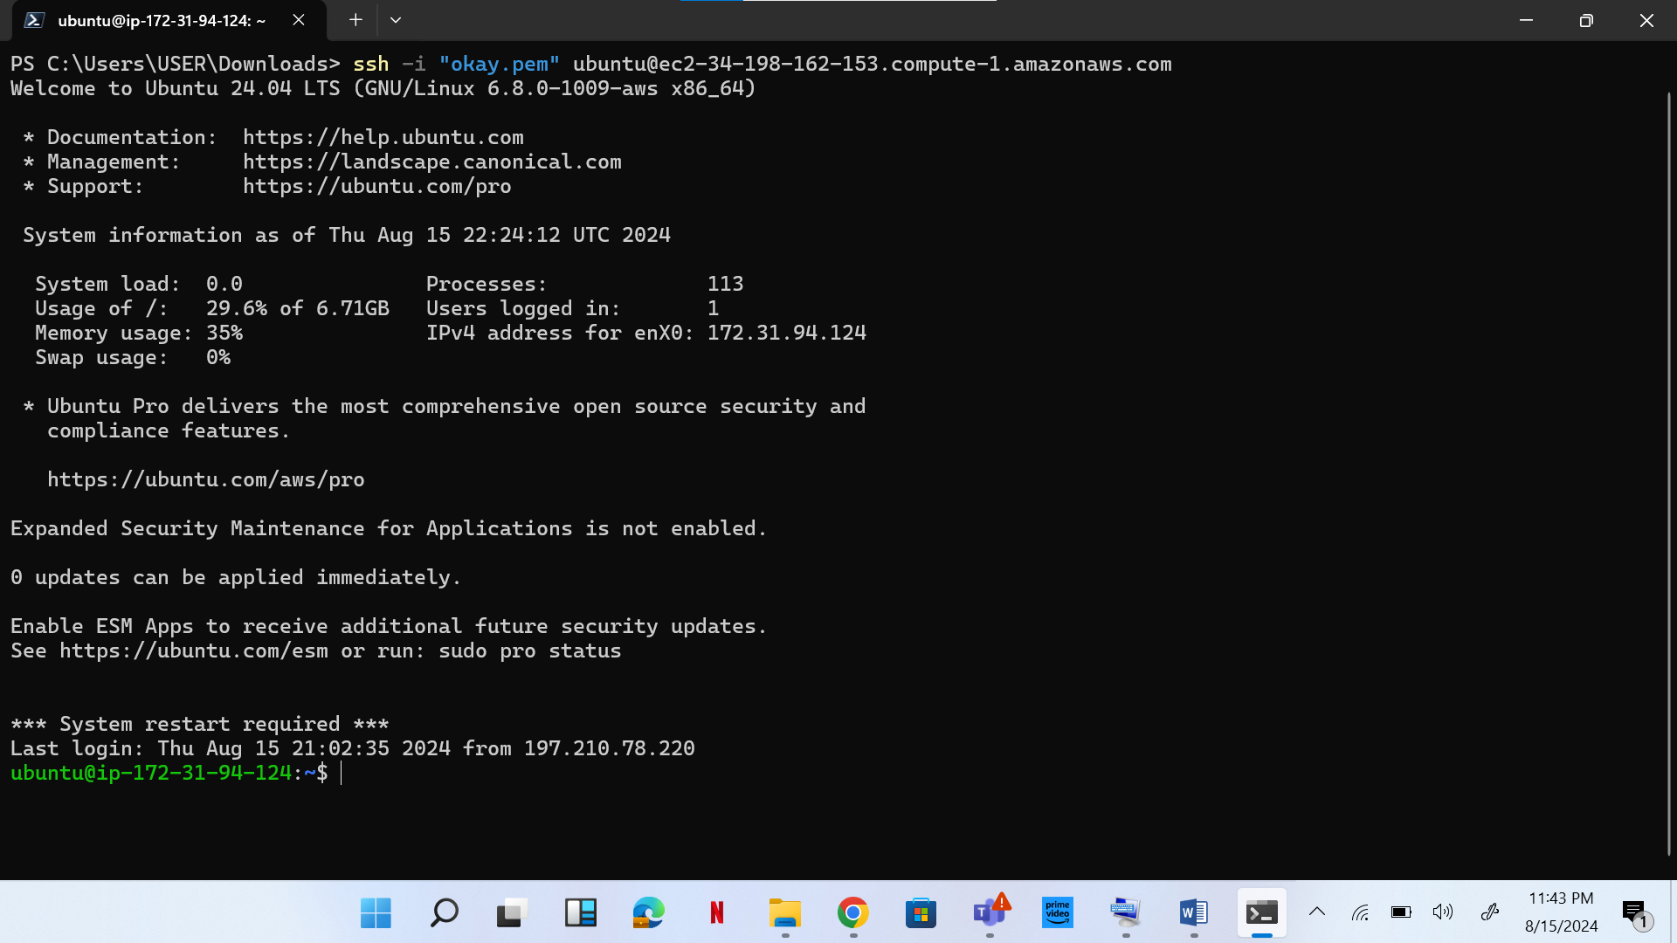

Again I entered the command copied from SSH client, pasted it on terminal and clicked enter.

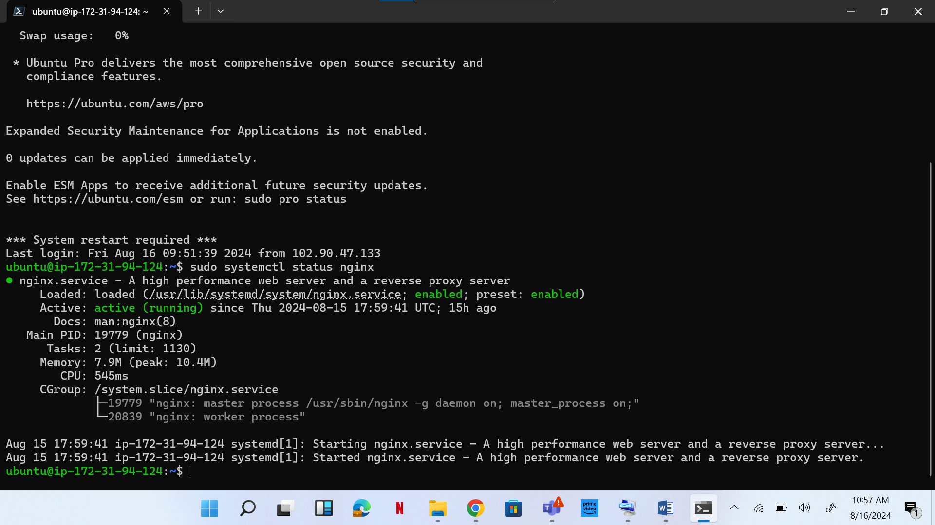

Nginx set up.

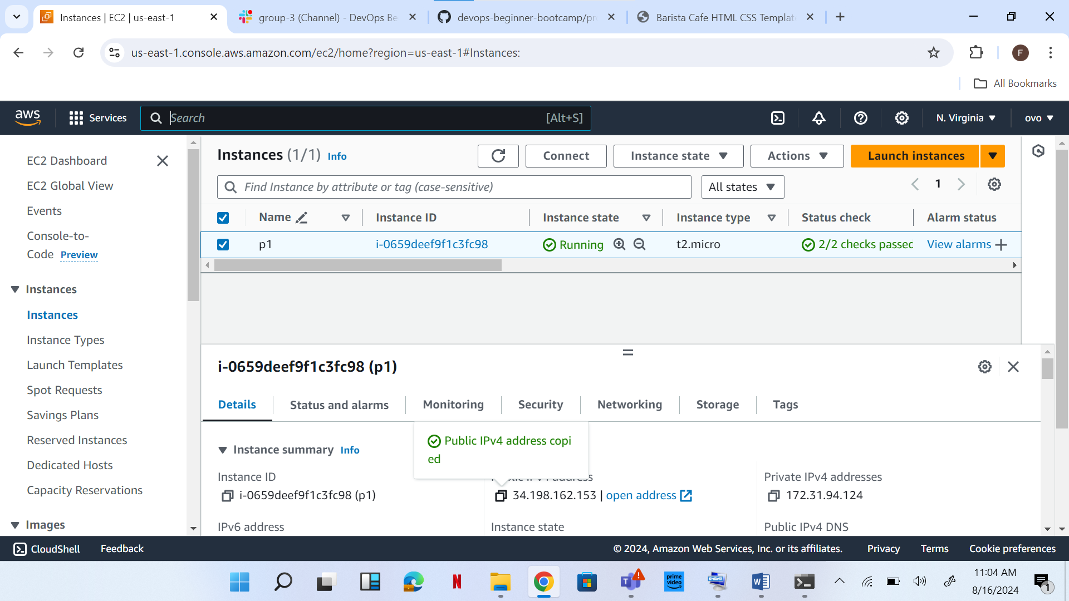

IP address copied and pasted on web browser and it showed welcome to nginx.

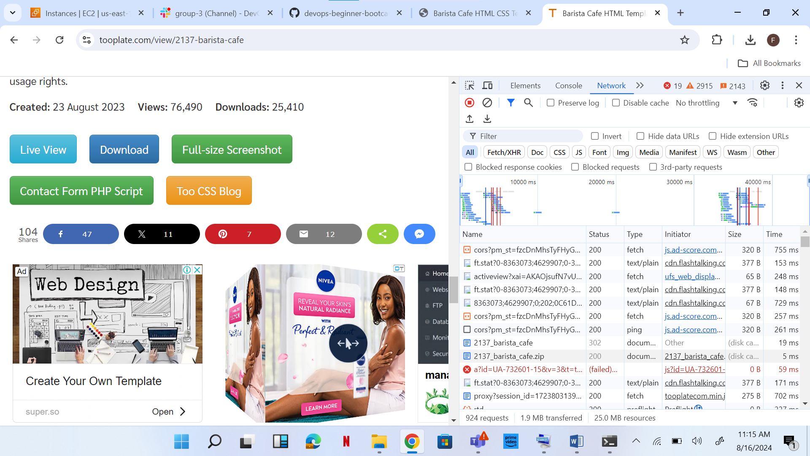

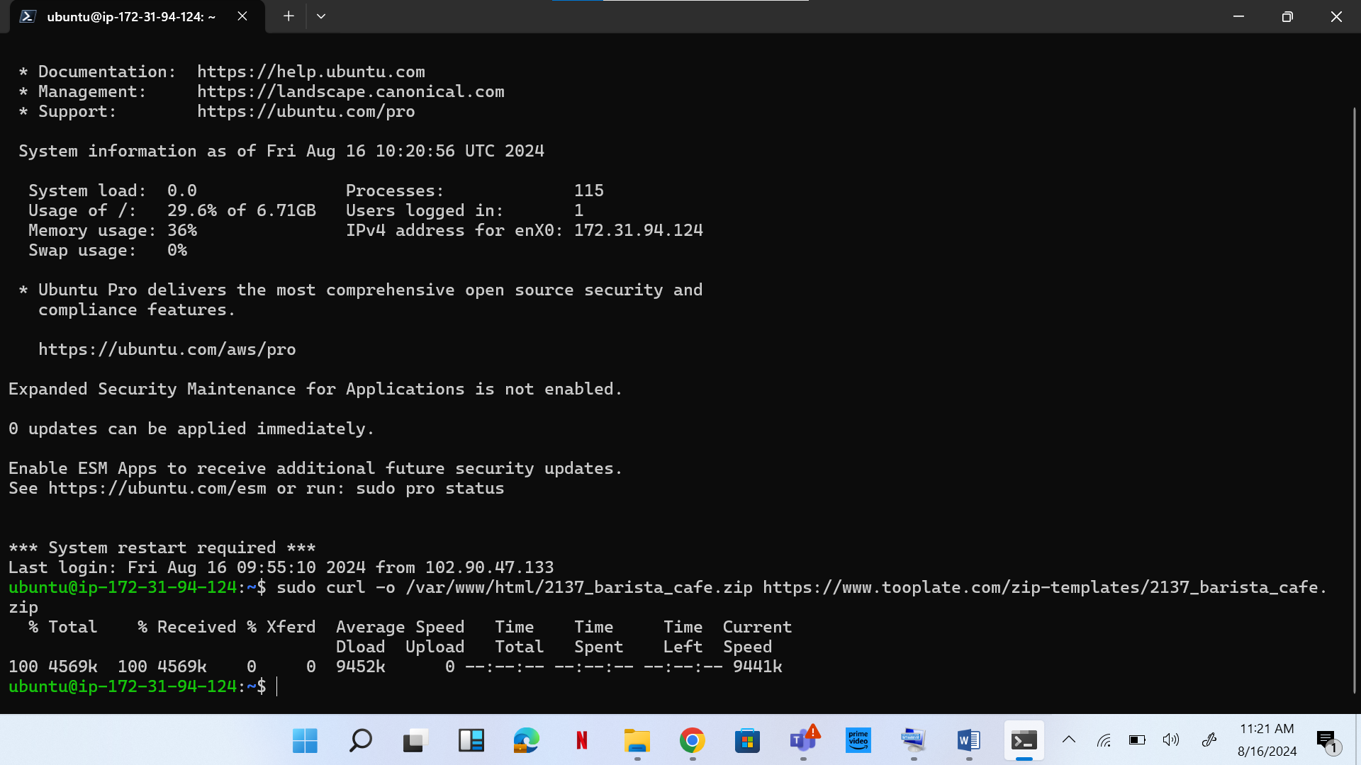

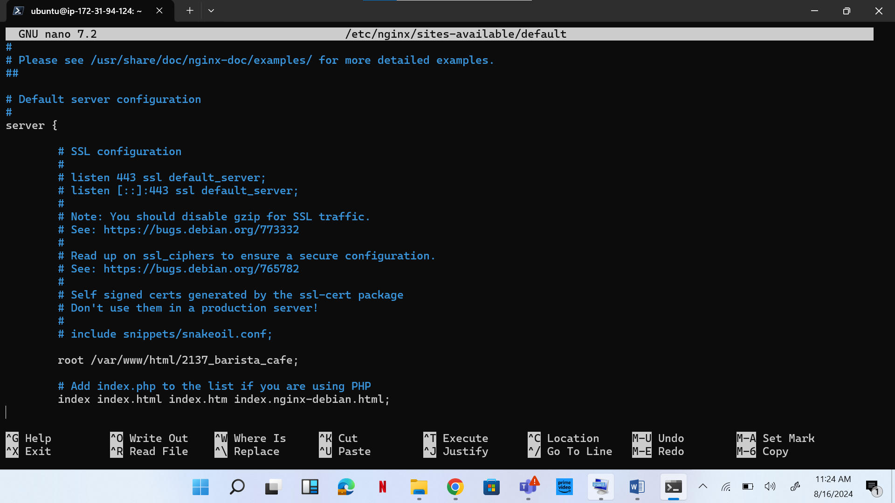

**sudo nano /etc/nginx/sites-available/default pasted on terminal and root directory edited.**

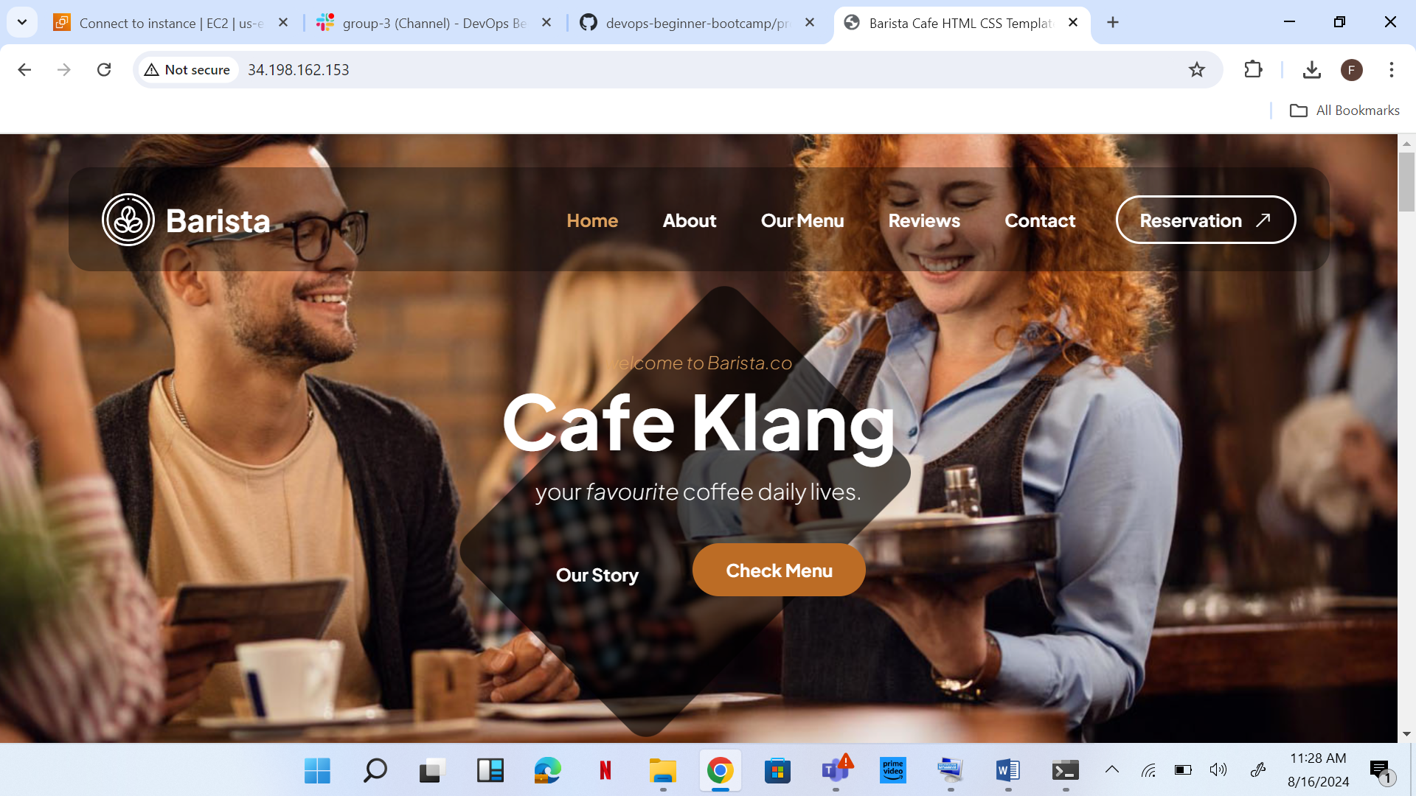

IP address copied and pasted on a browser.

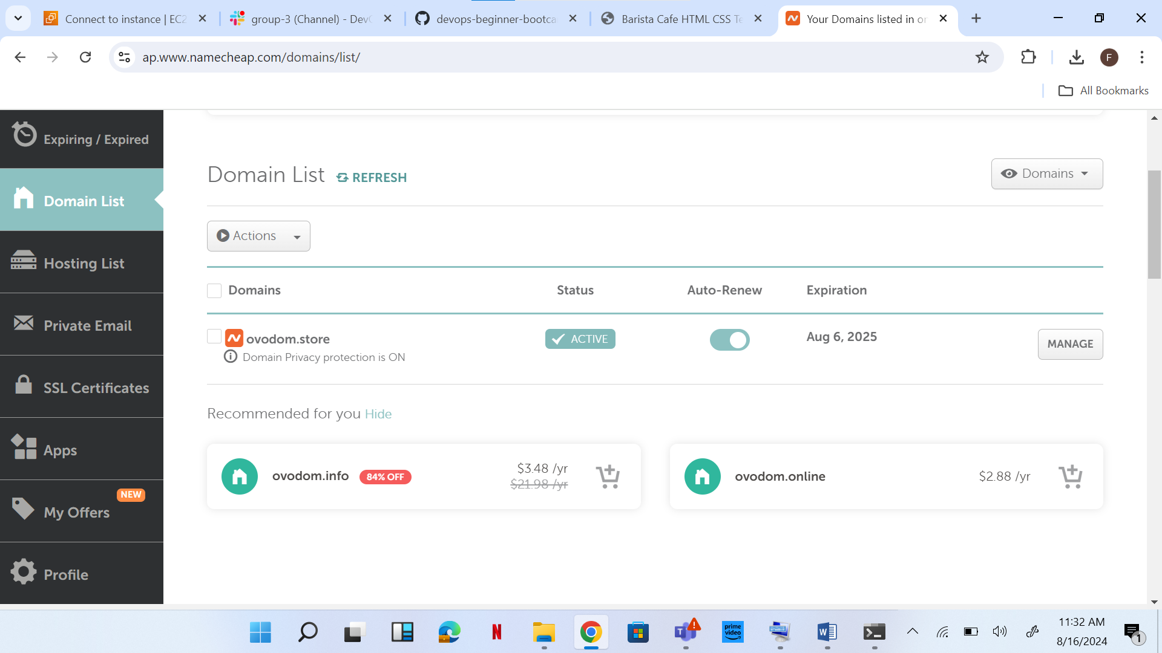

Changes made on my Domain.

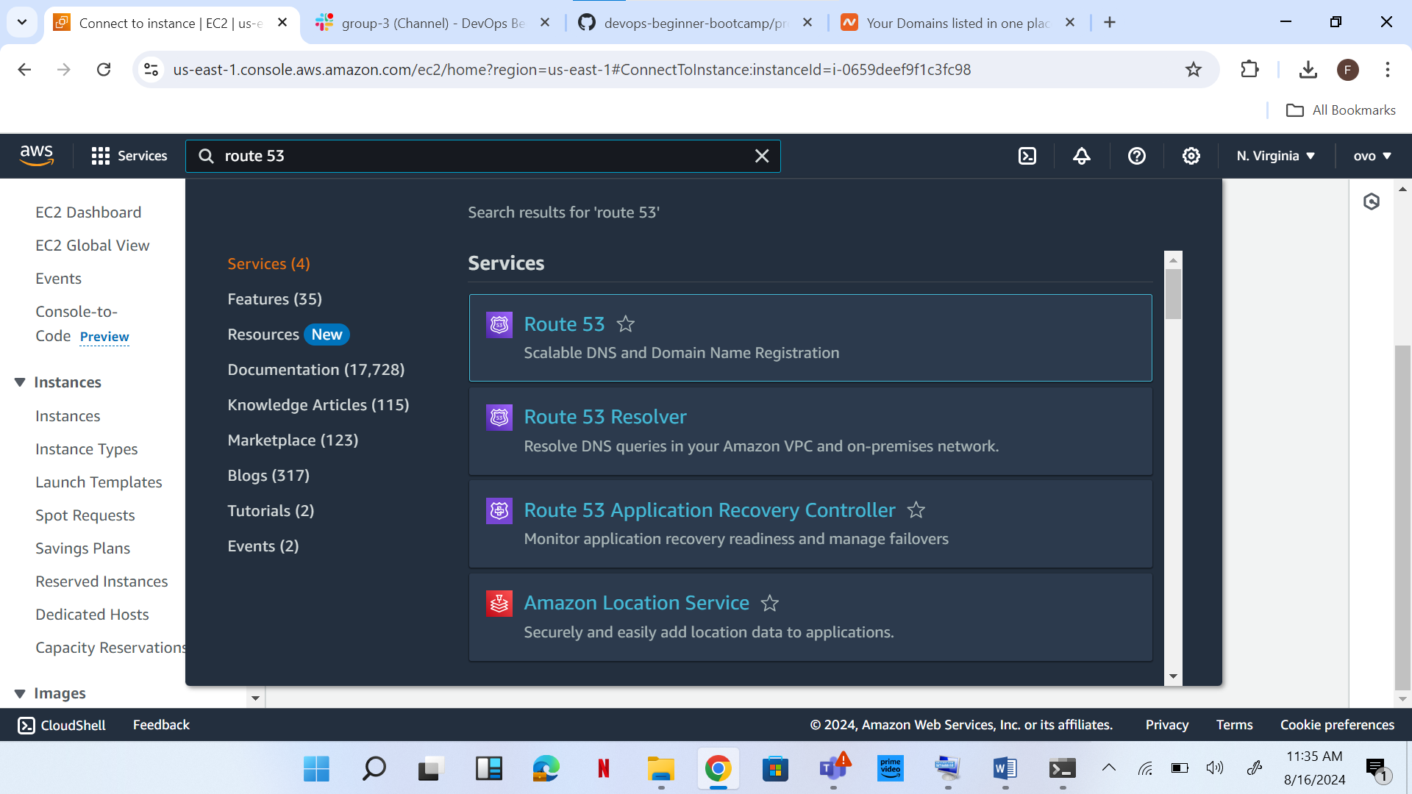

Domain entered in Route 53 [AWS].

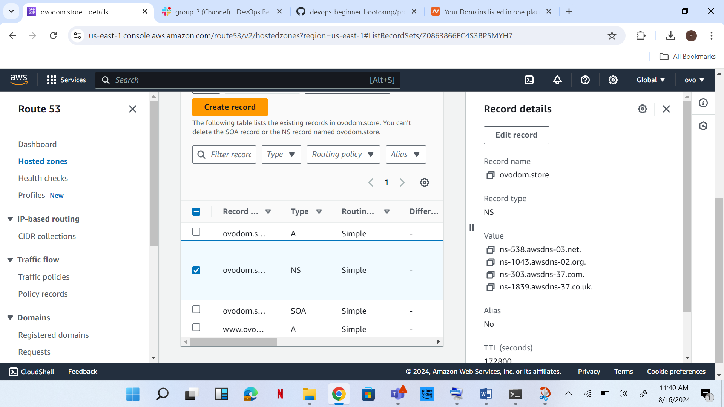

Back to domain, drop custom DNS, records under value from AWS copied and pasted on it.

On AWS, domain record created.

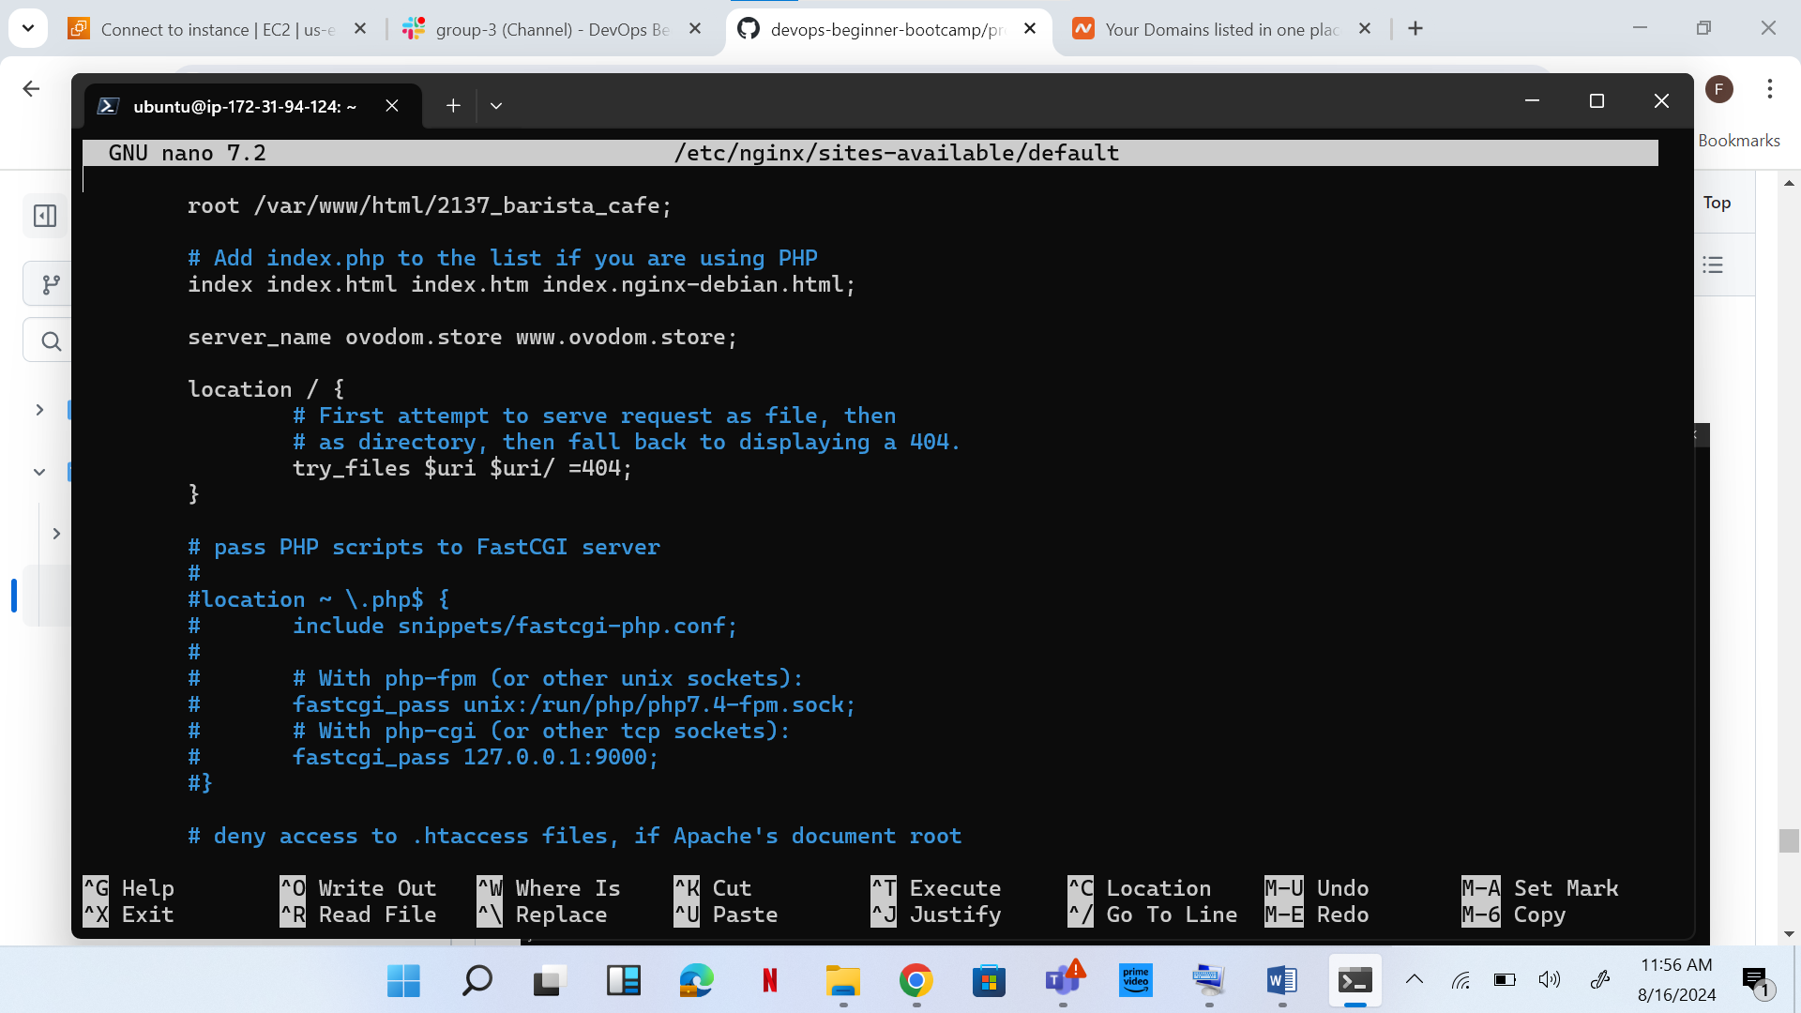

Command run terminal: **sudo nano /etc/nginx/sites-available/default and server name edited to domain name, ovodom.store** [**www.ovodom.store**](http://www.ovodom.store) **and saved.**

**sudo systemctl restart nginx run on terminal.**

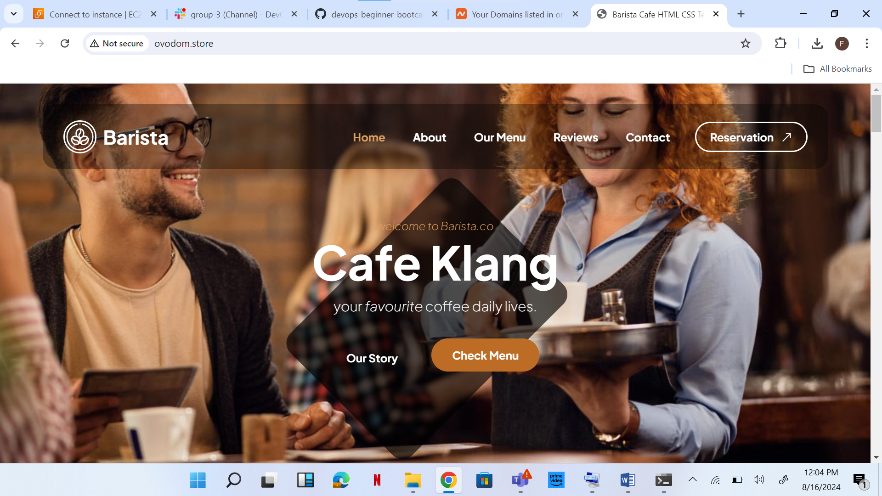

**Domain name entered on web browser.**

**sudo apt install certbot python3-certbot-nginx run on my terminal.**

**Next sudo certbot –nginx was ran on the terminal, where certificate was successful and deployed.**

**Finally ran openssl s_client -connect ovodom.store:443.**



**Visit to domain using https://ovodom.store**